Program Name: A program to print 2D array in Java
Code:
public class printing2DMatrix {
public static void main(String[] args){
int[][] matrix = {{1,2,3},{4,5,6},{7,8,9}};
for(int i=0; i< matrix.length; i++){
for(int j=0; j<matrix[i].length; j++){
System.out.print(matrix[i][j] + " ");
}
System.out.println();
}
}
}

Output:
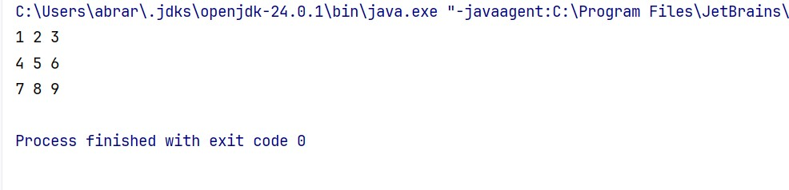

Program Name: A program to transpose a matrix and print it in Java
Code:
public class printing2DTranspose {
public static void printMatrix(int[][] matrix) {
for (int[] row : matrix) {
for (int element : row) {
System.out.print(element + " ");
}
System.out.println();
}
}
public static void main(String[] args) {
int[][] matrix = {{1, 2, 3},{4, 5, 6},{7, 8, 9}};
System.out.println("Original Matrix:");
printMatrix(matrix);
int rows = matrix.length, cols = matrix[0].length;
int[][] transposed = new int[cols][rows];
for (int i = 0; i < rows; i++) {
for (int j = 0; j < cols; j++) {
transposed[j][i] = matrix[i][j];
}
}
System.out.println("\nTransposed Matrix:");
printMatrix(transposed);
}
}

Output:
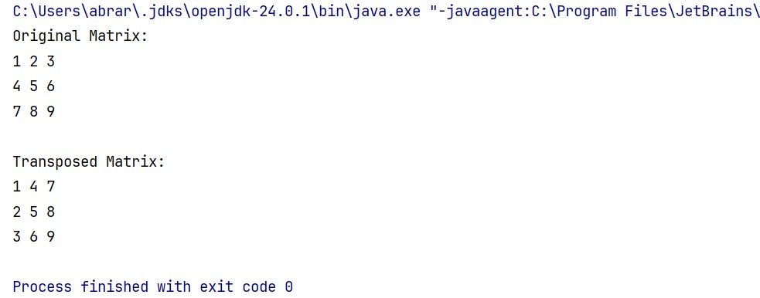

Program Name: A program to print the Sum of Diagonal elements in Java
Code:
public class matrixDiagonalSum {
public static void DiagonalSum(int[][] matrix){
int pSum = 0, sSum = 0;
int n = matrix.length;
for(int i=0; i<n; i++){
for(int j=0; j<n; j++){
if(i==j) // Principle Diagonal
pSum += matrix[i][j];
if(i+j == n-1) // Secondary Diagonal
sSum += matrix[i][j];
}
}
System.out.println("Sum of Principle Diagonal " + pSum);
System.out.println("Sum of Secondary Diagonal " + sSum);
}
public static void main(String[] args){
int[][] matrix = {{2,4,5},{14,15,16},{33,56,78}};
DiagonalSum(matrix);
}
}

Output:
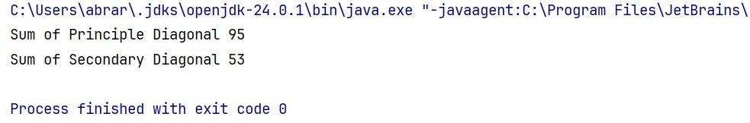

Program Name: A program to print the Triangular Sum of a matrix in Java
Code:
public class matrixTriangularSum {
public static void triangularSum(int[][] matrix){
int upperSum = 0, lowerSum = 0;
int n = matrix.length;
for(int i=0; i<n; i++){
for(int j=0; j<n; j++){
if(i <= j) // Upper Triangular Sum
upperSum += matrix[i][j];
if(j <= i) // Lower Triangular Sum
lowerSum += matrix[i][j];
}
}
System.out.println("Sum of Upper Triangular " + upperSum);
System.out.println("Sum of Lower Triangular " + lowerSum);
}
public static void main(String[] args){
int[][] matrix = {{1,2,3},{4,5,6},{7,8,9}};
triangularSum(matrix);
}
}

Output:
